**LAF Automation Tool**

**Overview**

WinForms front end

Spreadsheet determines which tests to run and contains associated application data

Can be used in Dev,System Test, UAT and PROD environments– requires a user with relevant permissions in LAF to run.

Test suite originally written with LTP in mind so is not complete but covers the following main areas:

* LAF Authentication of a set of key applications (LAF Login + check that app is logged in + logout)
* Testing key LAF Admin features (CRUD operations using a dummy test application)
* Restricted Agent Tests for ATLAS (Read + Write), Secure Store (Write) and LATCH (Read + Write)

The tool has evolved and to be honest, it is not written in the most maintainable way and if I had time, I would go through and tidy quite a lot of it up and make it more efficient.

But it does the job in terms of a smoke test for the key LAF functions. I do not imagine that it will be added to, but it can be by adding more methods to the TestCases Class in code.

**Usage**

1. Launch Application (.exe)

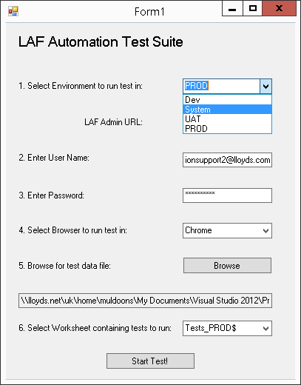

1. Select environment and enter a username and password – this is the username that the test will use to authenticate in LAF. I have setup some users in each environment with the required rights. See User section later in doc.
2. Select Browser.

(Tool tested with browser versions: IE - 11.0.96, Chrome – 56.0.2924.87)

*(NB. Prob won’t ever be an issue but in case a new IEDriver or ChromeDriver version is needed – happens if browser is updated, and can be downloaded via Nugetpackages, so I have added app settings in app.config so the location of each can be easily changed)*

1. Browse for the Data input file and select the worksheet from the dropdown containing the tests you want to run. The worksheet will have a ‘$’ symbol after it. Ensure to select the test case worksheet you want, and not any of the others. See Input File section later in document.
2. Click Start to begin the test – the test will write back to the Input spreadsheet during execution, so it is a good idea to close this file. Otherwise, ensure that you have not clicked to edit any of the cells as this locks the file and prevents the test from functioning.
3. When the test is complete, as results form will be displayed, showing the totals and also presenting a link to the application log file and screenshots.

Screenshots are taken of the screen on input at the time of an exception that is deemed to make the test a failure

(Nb. not every exception – there are exceptions that occur from time to time during the test that are handled and will not fail the test – e.g. In System Test and UAT, it is common for the driver to timeout due to the number of bad URLS that need to be hit during logout).

**The input spreadsheet**

The tool does not care what the name of this spreadsheet is, so multiple can be prepared if desired.

**Test Case Worksheets**

***NB. I have pre-prepared a number of these worksheets for different scenarios for LTP testing and ASG Patch verification, so it may not be necessary to create or change any of them. See ‘Pre-prepared Test Suites’ section later in this document.***

The test case worksheet(s) drive execution of the testing. There can be as many of these as needed, since the tool allows you to select which worksheet to run on a given execution run.

The TestMethod name column sets which test to run

The ExecutionMode column sets if the test should be skipped on this run or not.

The Result column shows the result of that individual test and the Fail Reason will for certain failures show the point at which the test failed.

Previous run shows the result of the previous run (it’s value is copied from the Result column at the start of the test)

ExecutionTime shows the execution time of each test.

The following columns are parameters that are relevant to certain tests:

* Application: The LAF Application that is relevant for that particular test
* TestUser: This is not the main user the test will execute with, but is the dummy user that will be created / deleted /added to group /etc… by the LAF Admin tests. This parameter is only relevant to those tests.
* UserGroupA + CredentialA + Credential ValueA : Again, these parameters are only relevant to some of the LAF Admin tests.

**Applications Worksheet**

This contains the data that many of the tests need to run. The columns read by the tool are:

* Application – The application name
* ApplicationURL for each environment – column names:
* AssertionText for each environment – text to search for in the LoginLogout test to prove that the application has successfully logged in

The other columns are not used by the tool and are just for info purposes. Deleting them will not affect execution of the tool (if desired).

Note the ‘Authenticates’ column denotes if the application immediately demands authentication or not (some applications do not – they allow the users to chose whether they want to log in or not, such as Lloyds.com)

**Environments Worksheet**

This worksheet must be kept up to date with and simply contains the Admin URL and Secure URL for each environment. The Environment names must stay as they are in the Environment column.

Altering the LAFAdminURL and SecureURL for each environment is the way to switch between LTP and legacy.

At present, System Test and Dev are set with the LTP URLs and PROD and UAT with the Legacy URLs.

**Drop Down Data Worksheet**

Reference data used by the other worksheets – no need to change – unless new tests are added to the test suite, in which case the name of the new test should be added to the list (and the Test Method Name column cells in the Test Cases worksheets updated to point to the full list)